Class CS_UC211 Number 202115030121 Name Hao Yang Data 2022/11/26

**Experiment topic：**

Implement a sequence table.

**1. Problem analysis**

1.1 Statement

Learn the linear table. In order to further understand and be familiar with linear tables.

1.2 Abstraction

Because the size of the data is uncertain, it is represented by the sequential structure of a dynamic array. Initialization, insertion, deletion, and inversion of linear tables are implemented.

1.3 ADT design

Because of the uncertainty of the data type, we do not know whether it is an integer type or a floating point type, or a user-defined data type, so we use the C++ template to abstract the data type. The abstract data structure contains the maximum array size, the current array length, and array pointer variables. Member functions include determining the maximum array size, inserting, deleting, inverting, and so on.

**2.** **Experimental scheme**

2.1 Storage Scheme

The access and search speed of sequential storage is fast. The access and search speed of the chained structure is slow, but the insertion speed is fast, and the storage efficiency is higher than that of sequential storage.

2.2 Algorithm design

* bool isFull() const;

Judgment_ Length and_ MAX_ Whether LENGTH is equal in length. Equal means the array is full, otherwise, it means it is not full.

* void Insert(int pos,const T& P);

Determines whether the array is full. If it is full, it returns. Otherwise, it inserts. If pos is greater than_ Length, assign pos as_ length。 Press from_ The pos of length decreases, and each element moves one bit backward to insert new elements into pos.

* void Delete(int pos);

From pos to_ Length moves forward in increasing order.

* int getLocation(const T& P) const;

Press from 0 to_ Length traverses sequentially. When the target element is found, its array subscript is returned.

* void Reverse();

Take_ The intermediate value of length is traversed from 0 to its value, and the front and rear elements are exchanged in turn.

* void interValue(const T& Min, const T& Max);

Create a new array, store the qualified elements in the new array, clear the old array space, and assign the new array to the old array.

2.3 Test scheme

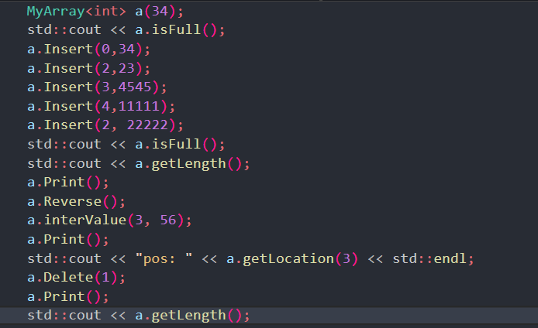

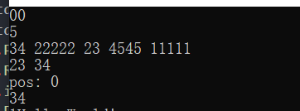

**3. Task solutions**

**The experimental task has been completed.**